<=============================================================================>

**=====>Title**

DSOD: Learning Deeply Supervised Object Detectors from Scratch

**=====>Main Contributions / New Opinions**

1.未使用ImageNet模型进行参数初始化，而是直接利用Pascal VOC 2012数据集进行训练，得到的效果媲美其他四类检测方法

**=====>Key Points**

1.Proposal-free

Faster R-CNN以及R-FCN方法在VOC数据集上直接初始化训练，会失败。作者认为这与ROI Pooling相关，因为ROI Pooling需

要输入region proposal，而proposal-free类型的方法（SSD，YOLO）可以

2.Deep Supervision

参考DenseNet，利用skip connections实现supervised signals传递。Transition w/o Pooling Layer用这个层来增加dense

blocks数量。原来的DenseNet的dense blocks数量是固定的

3.Stem Block

Stem Block受Inception-v3和v4的启发，定义Stem Block为三个3×3卷积层和一个2×2最大池化层，发现这么设计可以提升性能

4.Dense Prediction Structure

Learning Half and Reusing Half

In DSOD, in each scale (except scale-1), half of the feature maps are learned from the previous

scale with a series of conv-layers, while the remaining half feature maps are directly down-sampled from the contiguous high-resolution feature maps.

The pooling layeraims to match resolution to current size during concatenation.The 1X1 conv-layer is used to reduce the number of channels to 50%.

**=====>Result**

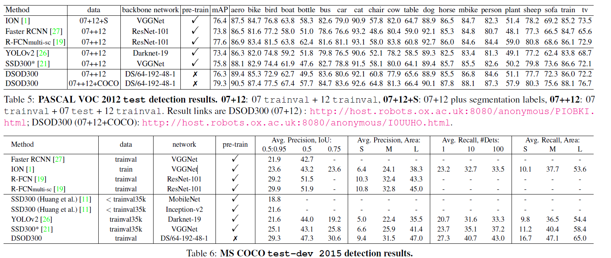

<=============================================================================>

**=====>Title**

Feature-Fused SSD: Fast Detection for Small Objects

**=====>Main Contributions / New Opinions**

1.Feature Fusion

Conv4_3、Conv5_3 Concatenation

Conv4_3、Conv5_3 Element-wise sum

**=====>Key Points**

1.Concatenation

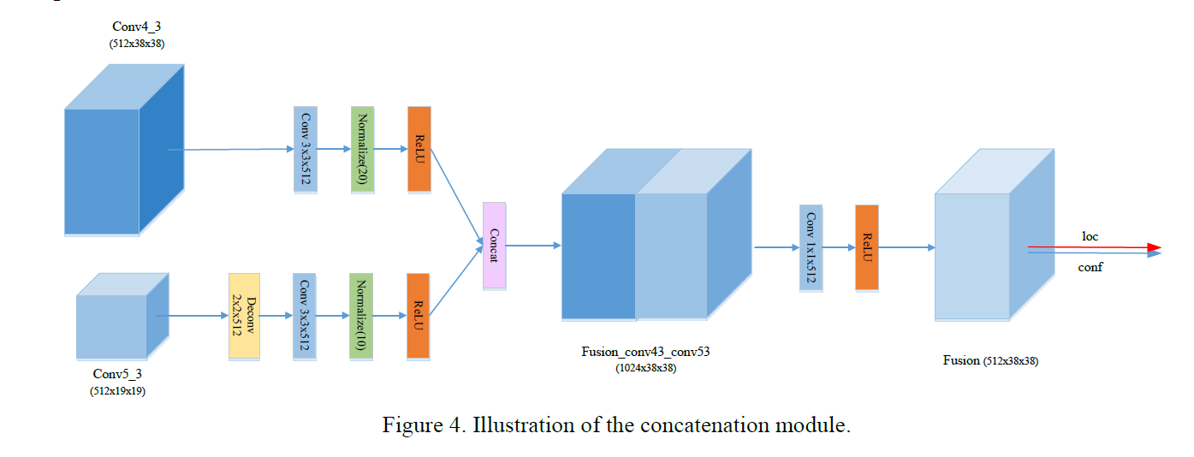

2.Element-wise sum

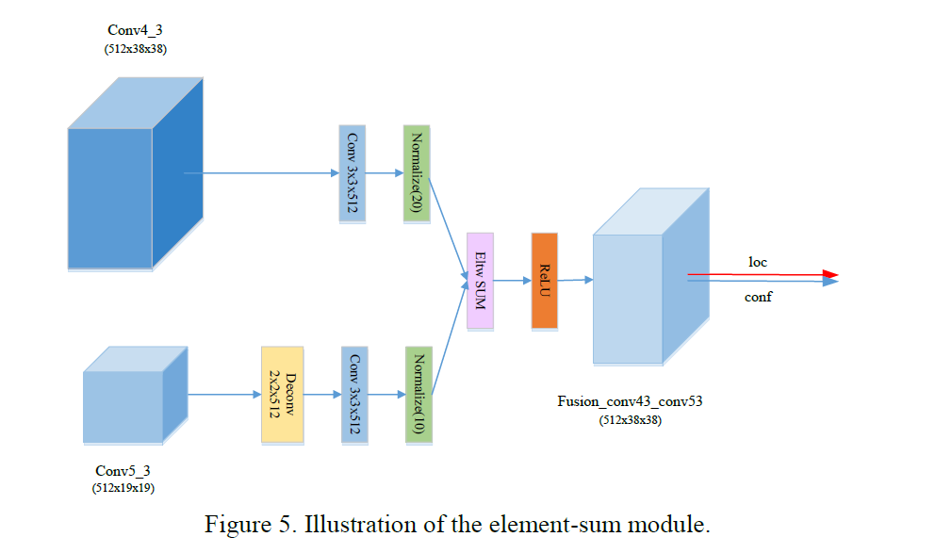

**=====>Result**

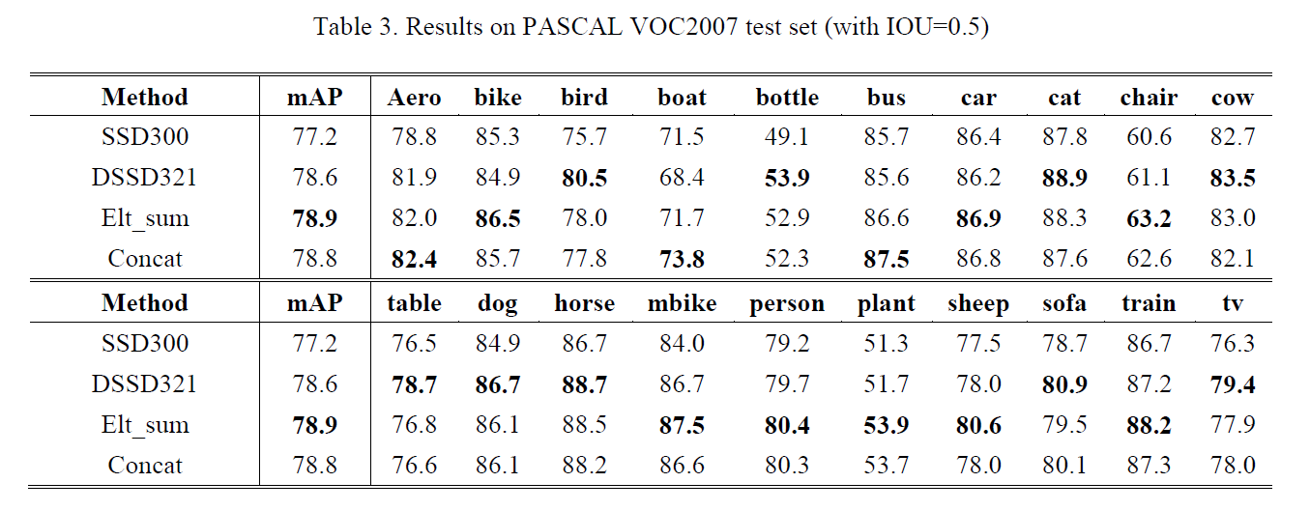

<=============================================================================>

**=====>Title**

LocNet: Improving Localization Accuracy for Object Detection

**=====>Background**

1.localization accuracy 少人问津

2.PASCAL VOC IOU=0.5 (object has been successfully detected)

3.Real life higher localization accuracy (e.g. IoU> 0.7) is normally required

4.COCO detection challenge 把IOU值也作为了最终的评价指标（MAP+IOU）

5.提高目标检测的IOU（而不仅是MAP）将会成为未来目标检测的主要挑战

6.传统的bbox回归：尝试直接通过回归的方式直接得到bbox的坐标，很难得到很准确的bbox

**=====>Main Contributions / New Opinions**

1.可以很方便的和现在最先进的目标检测系统结合

2.提出了两种基于行列的概率模型解决定位准确率，而不是回归的方式，并与回归方式进行了对比

3.对传统方法和最先进的方法不同iou下的map都有所提高

4.未来可以完全取代bbox回归的方法

**=====>Key Points**

1.两种概率模型

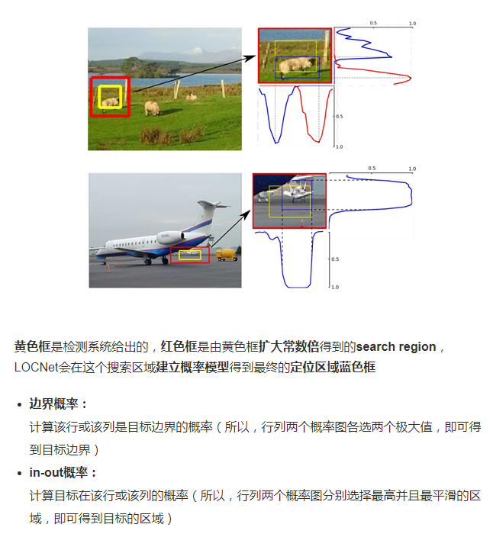

2.Detection Pipeline

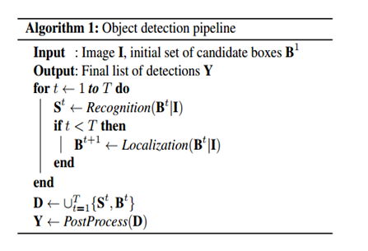

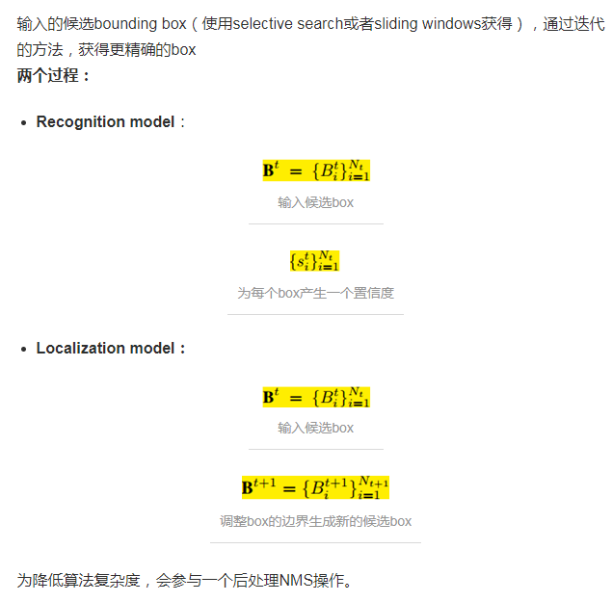

3.Model Prediction

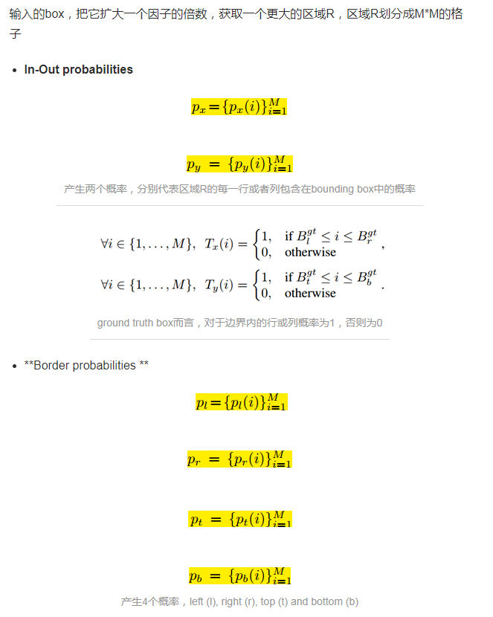

4.Network Architecture

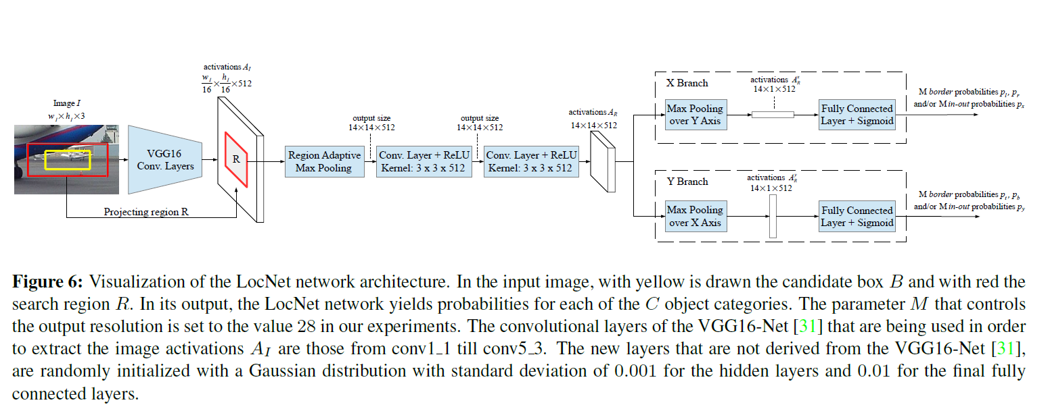

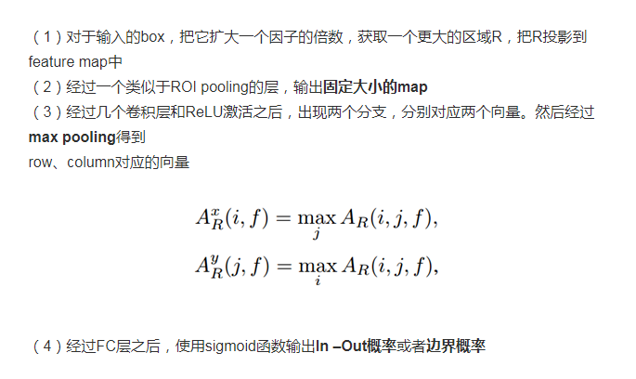

5.Loss Function

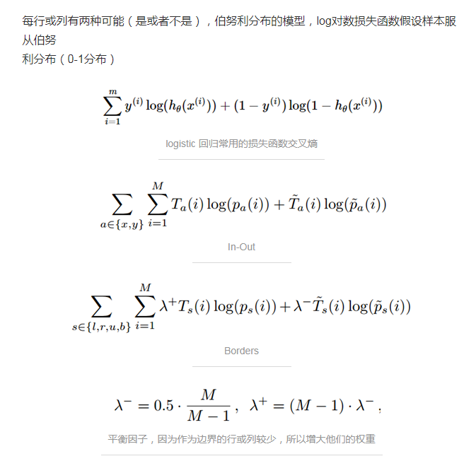

**=====>Result**

